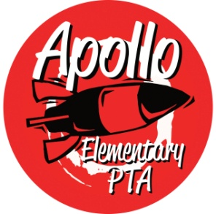
Apollo Elementary PTA
General Meeting Agenda
January 31st, 2024

6:30-6:35pm Call to Order

6:35-6:45PM Special Guest Speaker: Sydney Hall, Apollo Counselor

6:45-6:55pm Presidents’ Report—Rachel Hearn
- Election of 2024 nominating committee
- PTA Golden Acorn Awards
- Special Funding Grants
- Amend standing rules

6:55-7:00pm Treasurers’ Report – Alecia Heyel
- December 2023 report
- Updated 2023-24 Budget

7:05pm-7:10pm Secretary’s Report
- Approval of Minutes from September 27, 2023

7:10pm-7:20pm Director Introductions
- Programs - OPEN
  - Reflections
  - Read at Home
  - Math in Action & STEM Fair
  - Staff appreciation
  - Book Fair
  - School Supplies
  - Yearbook
  - Popcorn Friday
- Events – OPEN
  - Talent show
  - Multicultural Night
  - Winterfest Recap
- Fundraising – Sarah Silverman
- Communications – Laura Ni and Karla Inostroza
- Volunteers – Laura Ni

7:20-7:30pm Standing Committee Introductions
- ISF – Laura Ni
- Membership – Peter Tran
- Art Docent – Jessica Braswell
- Family & Community Engagement (FACE) – Laura Ni
- Outreach – Yomn Osman and Lisa Lee
- Parent Ed/Parent Wiser—Tina Correa
- Special Education – Jennifer Khumalo & Jessica Braswell
7:30pm-8:00pm Rocket Report-Principal Harris
8:00pm-8:10pm Q & A for Principal Harris
8:10pm-8:15pm New Business
8:15pm Adjourn at 8:15PM

Attendance List:

