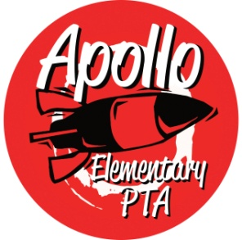
Apollo Elementary PTA
General Meeting Agenda
February 2, 2022

6:30-6:35pm Call to Order

6:35-7:05pm Guest Speaker—Rebecca Kennedy, ELL teacher and GLAD (Guided Language Acquisition Design) Building Leader

7:05-7:15pm Presidents’ Report—Laura Ni & Laurelle Graves
- Election of 2022 nominating committee
- PTA Golden Acorn Awards – Nominations close on 2/13. Form can be found on our website
- Special Funding Grants To Date since last meeting
  - 1st grade: BOB book sets
  - 4th grade: level reading books sets

7:15-7:20pm Treasurers’ Report – Erin Wang
- January 2022 report

7:20-7:25pm Secretary’s Report – Jen Davis
- Approval of Minutes from September 29, 2021

7:25pm-7:35pm Director Introductions
- Programs – OPEN (Laura)
  - Reflection
  - Read at Home
- Events – Rachel Hearn
- Fundraising – OPEN
  - Fall Rocket Fuel Fundraising & Learning Express Toy Store
  - Spiritwear
- Communications – Laura Ni & Jennifer Khumalo
- Volunteers – OPEN (Laura)

7:35-7:45pm Standing Committee Introductions
- ISF – Michelle Kauffman
- Membership – Jennifer Khumalo
- Art – Laurelle Graves & Yomn Yasser
- Family & Community Engagement (FACE) – OPEN (Laura)
- Outreach – Karen Baker & Yomn Yasser
- Parent Ed/Parent Wiser—Laurelle Graves
- Teacher Liaison – Jen Davis
- Special Needs—Kimbie Pope & Andrea McMillan
- Safety – Andrea McMillan

7:45-8:15pm Rocket Report—Principal Harris
8:15 – 8:20 New Business
8:20pm Adjourn

