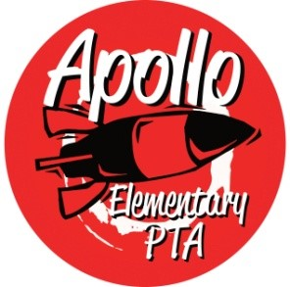
Apollo Elementary PTA
Membership Meeting Agenda
6:30 PM, Zoom
April 27, 2022

6:30: Call to Order
Presidents’ Report - Laura Ni & Laurelle Graves
- Election of 2022-23 Apollo PTA Board
Secretary’s Report
- Approval of Minutes from February 2, 2022
Treasurers’ Report—Erin Wang
- Treasurers Report from March 2022
Director & Committee Reports
- Programs – Open
- Fundraising – Open
- Communications – Laura Ni & Jennifer Khumalo
- ISF – Michelle
- Membership – Jennifer Khumalo
- Golden Acorn Award – Amita Nair & Yomn Osman
- Art – Laurelle Graves
- Family & Community Engament (FACE) - Open
- Outreach – Yomn Osman
- Parent Ed/Parent Wiser—Laurelle Graves
- Safety—Laurelle Graves
- Teacher Liaison – Jenn Davis
- Special Needs—Kimbie Pope & Andrea McMilan

7:00 pm: Rocket Report presented by Principal Harris
8:30 Adjourn

