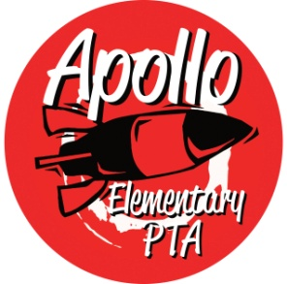
Apollo Elementary PTA
General Meeting Agenda
February 1, 2023

6:30-6:35pm Call to Order

6:35-6:45pm Presidents’ Report—Laura Ni & Rachel Hearn
- Election of 2023 nominating committee
  - Andrea MacMillan, Cheryl Singh, and Karla Inostroza
  - email nomcomm@apollopta.org
- PTA Golden Acorn Awards
- Special Funding Grants To Date since last meeting

6:45-6:50pm Treasurers’ Report – Erin Wang
- December 2022 report

6:50-6:55pm Secretary’s Report – Jen Davis
- Approval of Minutes from September 28, 2022

6:55pm-7:05pm Director Introductions
- Programs – OPEN (Laura)
- Events – Nancy Yeung and Minh Ngu
- Fundraising – Sarah Silverman
- Communications – Laura Ni, Jennifer Khumalo, and Karla Inostroza
- Volunteers – OPEN (Laura)

7:05-7:15pm Standing Committee Introductions
- ISF – Michelle Kauffman
- Membership – Jennifer Khumalo & Julie Chang
- Art Docent – Laurelle Graves
- Safety – Laurelle Graves
- Family & Community Engagement (FACE) – Aletta Collins
- Outreach – Yomn Osman and Lisa Lee
- Parent Ed/Parent Wiser—Laurelle Graves
- Teacher Liaison – Jen Davis
- Special Needs – Jennifer Khumalo & Andrea McMillan

7:15-7:45pm Rocket Report & Guest Speaker—Principal Harris
7:45-7:55pm Q & A for Principal Harris
7:55 – 8:00pm New Business
8:00pm Adjourn

