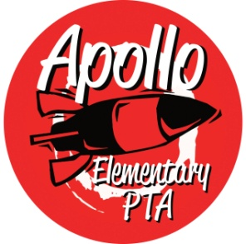
Apollo Elementary PTA
General Meeting Agenda
September 27, 2023

6:30-6:35pm Call to Order
Board Member Introductions

6:35-7:05pm Guest Speaker—A’me Dunn, Issaquah School District, Special Education PTSA

7:05-7:15pm Presidents’ Report & Welcome—Rachel Hearn
- Vote 2023-24 Goals and Mission Statement
- Vote 2023-24 Standing Rules
- Approve Calendar for 2023-24

7:15-7:25pm Treasurers’ Report – Alecia Heyel
- Annual Financial Review for 2022-23
- Vote 2023-24 Budget with the changes
  - Grade level change fund
  - 5th grade camp fund

7:25-7:30pm Secretary’s Report – Emily Mitchell
- Approval of Minutes from June 2023

7:30pm-7:45pm Director Introductions
- Programs – OPEN
  - Fall Scholastic Book Fair
  - Read at Home
  - Math In Action
  - Reflections
  - School Supplies
  - Emergency Backpack
  - Yearbook
  - Staff Appreciation
  - 5th grade camp
- Events – OPEN
  - Pumpkin Patch Festival
  - Winterfest
- Fundraising – Sarah Silverman
  - Fall Rocket Fuel Fundraising: 10/12 -10/26.
  - Spiritwear
- Communications – Laura Ni/Karla Inostroza
- Volunteers –Laura Ni
  - ISD Volunteer System
  - Volunteer opportunities: Picture Day, Vision and Hearing, Pumpkin Patch Festival, Popcorn Friday, Power Pack pickup, Book fair.

7:45-8:00pm Standing Committee Introductions
- ISF – Laura Ni
- Membership – Jennifer Khumalo/OPEN
- Art – Jessica Braswell
- Family & Community Engagement (FACE) – Aletta Collins/Laura Ni
- Outreach –Yomn Yasser & Lisa Lee
- Parent Ed/Parent Wiser—Tina Correa
- Teacher Liaison – Jen Davis
- Special Needs—Jessica Braswell & Jennifer Khumalo

8:00-8:10pm Rocket Report—Principal Harris

8:10 – 8:15 New Business

8:15pm Adjourn

