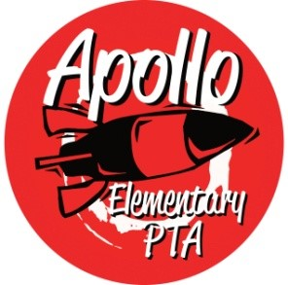**Apollo Elementary PTA**

Membership Meeting Agenda

7:00 PM, Zoom

May 24, 2023

**7:00 PM:** Call to Order

**7:00 PM – 7:15 PM:** Guest Speaker: Issaquah Special Education PTSA

**7:15 PM – 7:20 PM:** Presidents’ Report - Laura Ni & Rachel Hearn

* Election of 2023-24 Apollo PTA Board
* Calendar 2023-24 Draft

**7:20 PM – 7:25 PM:** Secretary’s Report

* Approval of Minutes from February 1, 2023

**7:25 PM – 7:35 PM:** Treasurers’ Report—Erin Wang

* Treasurers Report from May 2023
* Vote on 2023-24 Budget

**7:35 PM – 8:00 PM:** Director & Committee Reports

* Programs – OPEN
* Fundraising – Sarah Silverman
* Events – Minh Ugh & Nancy Yeung
  + Multicultural Night
* Communications – Laura Ni
* Volunteers – Laura Ni
* ISF – Michelle
* Membership – Jennifer Khumalo & Julie Chang
* Golden Acorn Award – Laura Ni & Jennifer Khumalo
* Art – Laurelle Graves & Jessica Braswell
* Family & Community Engament (FACE) – Aletta Collins
* Outreach – Yomn Osman & Lisa Lee
* Parent Ed/Parent Wiser—Laurelle Graves
* Teacher Liaison – Jenn Davis
* Special Needs—Jennifer Khumalo & Andrea McMilan

**8:00 PM:** Rocket Report presented by Principal Harris

**8:30 PM** Adjourn